Welcome to Word

& Snirt2333

&&& 77

5 tips for a simpler way to work

# Use live layout and alignment guides

Click the image below and drag it around the page. With images that have text wrapping, the text moves around the picture so you get a live preview of the new layout. Try to line the image up with the top of this paragraph to see how the alignment guides can help you position it on the page. Click the Layout Options button next to the image to change how it interacts with the text. [Learn more at office.com](http://o15.officeredir.microsoft.com/r/rlid2013LiveLayoutWd?clid=1033)

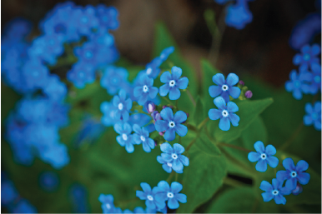

# Collaborate in Simple Markup View

The new Simple Markup revision view presents a clean, uncomplicated view of your document, but you still see markers where changes and comments have been made. Click on the vertical bar on the left side of the text to see changes. Or click the comment icon on the right to check out comments about this text.

[Learn more at office.com](http://o15.officeredir.microsoft.com/r/rlid2013SimpleMarkupWd?clid=1033)

# Insert Online Pictures and Video

Add and play online videos inside your Word documents. Add your pictures from online photo services without having to save them first to your computer. Click **Insert** > **Online Video** to add a video to this document.

# Enjoy the Read

Use the new Read Mode for a beautiful, distraction-free reading experience. Click **View** > **Read Mode** to check it out. While you’re there, try double clicking on a picture to get a closer view. Click outside the image to return to reading.

# Edit PDF content in Word

Open PDFs and edit the content in Word. Edit paragraphs, lists, and tables just like familiar Word documents. Take the content and make it look great.

Download [this helpful PDF from the Office site](http://o15.officeredir.microsoft.com/r/rlid2013PDFReflowWd?clid=1033) to try in Word or pick a PDF file on your computer. In Word, click **File** > **Open** and navigate to the PDF. Click **Open** to edit the content or read it more comfortably using the new Read Mode.

# Ready to get started?

We hope you enjoy working in Word 2013!

Sincerely,

The Word Team

# Learn More

Keep going. There are lots more new features and ways to work in Office. Check out our [Getting started with Word 2013](http://o15.officeredir.microsoft.com/r/rlid2013GettingStartedCntrWd?clid=1033) page online to dive right in.